Beginner Burger Tasks

How can you change the cost of the burger?
Change the size of the two headings to make them either larger or smaller.
Spell onion incorrectly. What happens and why?
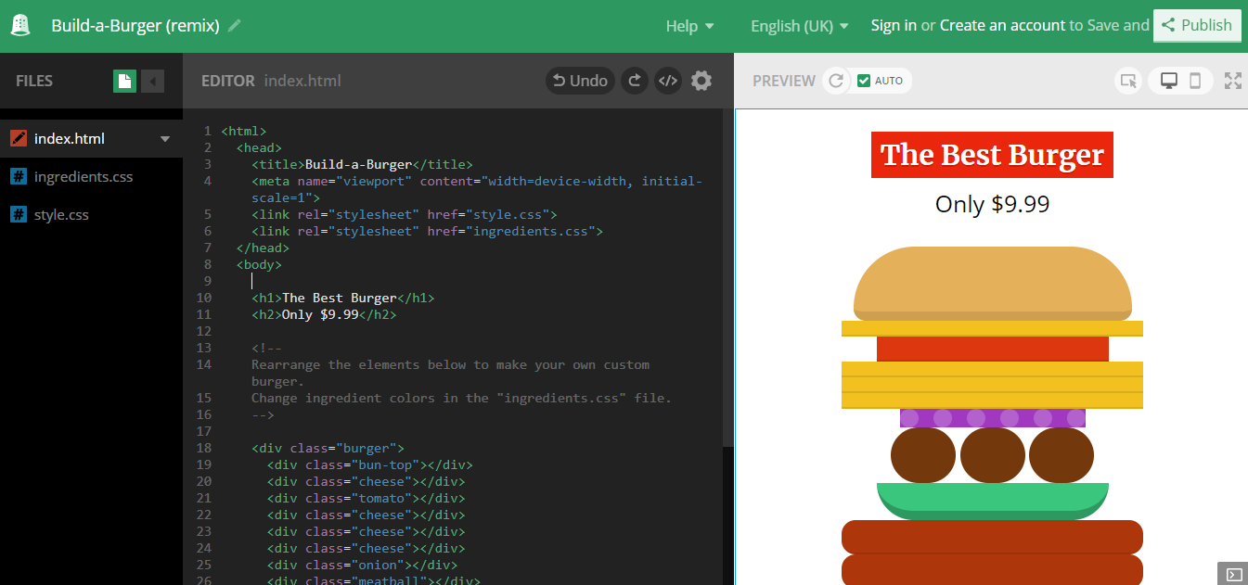
How big can you make your burger?

Move the order of the burger ingredients around from <div class = “burger”> using cut and paste (ctrl+X, ctrl+V).

Add extra layers of ingredients by copying first (ctrl+C).
